**Questions**

1. What is the smallest memory object that can represent a character of information?
   1. Think… How many upper case letters in the alphabet (A to Z)?
      1. 26
   2. Think… How many lower case letters in the alphabet (a to z)?
      1. 26
   3. Think… How many number digits (0 to 9)?
      1. 10
   4. Think… How many punctuation marks?
      1. 14
   5. Add them all up
      1. 76
         1. A bit is the smallest object used to store data.
2. Research the ASCII characters set. What is it and how is it related to computer memory?
   1. It is the characters that are used to communicate ideas and messages which are found on a keyboard. This relates to storage as characters and words both take up a certain amount of bits in a computer.
3. How are strings of characters (Google “String”) represented in computer memory?
   1. Strings of characters take up one byte of data
4. How are negative integers represented in computer memory? (Include a diagram)
   1. Negative integers are represented by long and short integer data types in a computer’s memory.   
      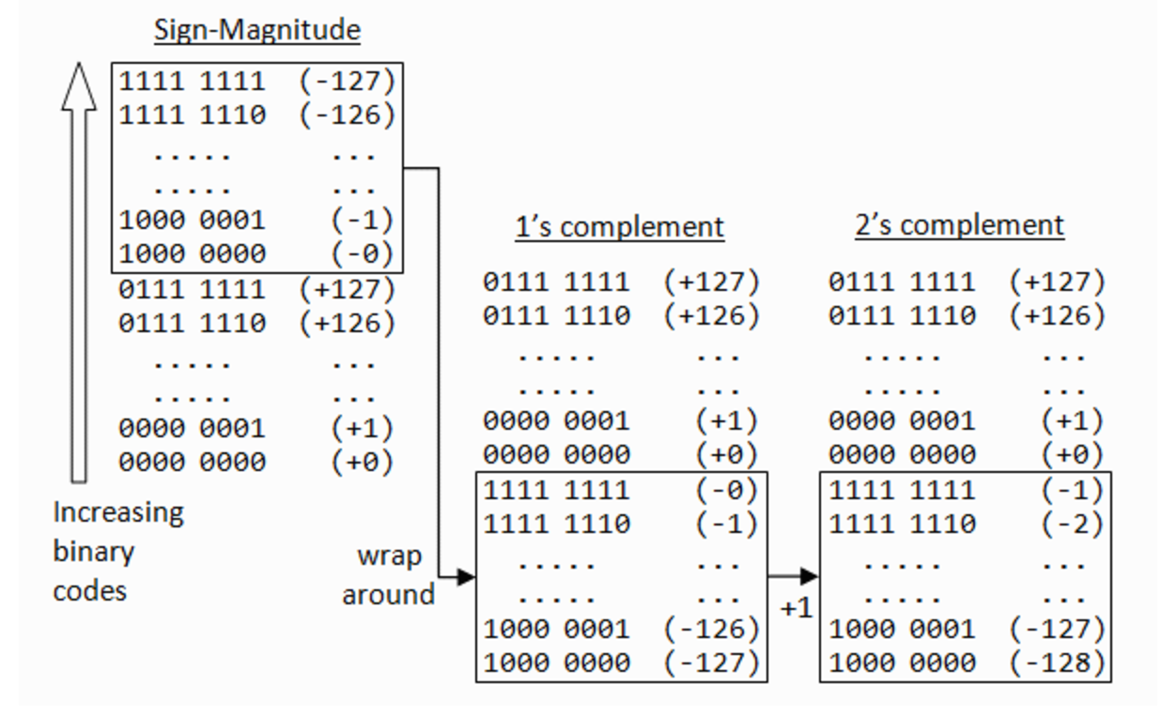
5. How are decimal numbers (Google “Floating Point”) represented in computer memory? (Include a diagram)
   1. In memory, a floating point number is represented similarly: One bit has the sign, some bits form the factor as a fixed-precision number (“mantissa”), the remaining bits form the exponent.

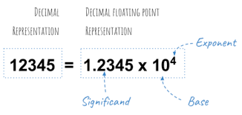

1. A Pixel is computer memory structure used to store image information. How is a Pixel represented in memory? (Include a diagram).
   1. Each pixel is represented by a binary value. We call this representation of colours a “bit-plane”. Each bit doubles the number of available colours i.e. 1-bit would give us 2 colours, 2-bits would give us 4 colours and 3-bits would give us 8 colours etc.

